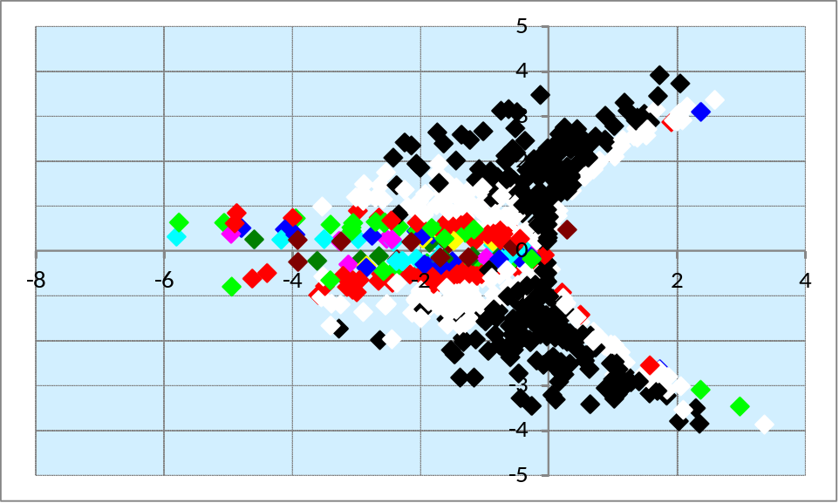
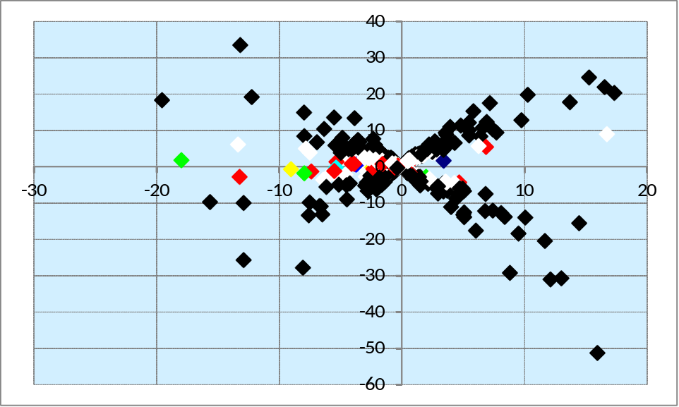
The upper graph contains the scatter plot for power iteration, whereas the bottom graph contains the scatter plot for inverse power iteration. Each dot represents one matrix that was inputted. The x axis shows its (or its inverses) determinant, while the y axis shows the trace. The color of the dot represents how many iterations were required to achieve a tolerance of .00005. Each color represents a range: black is 1-10, white 11-20, red 21-30, green 31-40, and so on with blue, yellow, purple, cyan, and brown. Black and white clearly form large groups in the scatterplot, which is very interesting.

(Most of the following refers to absolute values)
On the normal power iteration graph, black dominates the region where the determinant is similar to or less than the trace. White dominates an adjacent area, where the determinant starts to grow larger than the trace. As this difference grows (but only where it exists in the negative section), so does the number of iterations needed to attain an eigenvalue within our tolerance. The inverse power iteration graph shows essentially the same trends, but the graph's scale was slightly blown up due to the larger range of determinants and traces for the inverses.

So... why does this happen? It's related to the relationship between the trace and determinant, which represent the sum of the eigenvalues and the product of the eigenvalues, respectively. The power method takes less iterations when the determinant is less than the trace, or in other words when the product of the eigenvalues is less than the sum.

When in power iteration, the determinant is less than the trace (as with black dots), trace/determinant is greater than the original trace. The trace of the black dots in the inverse power iteration graph spans a larger range than that of the power iteration graph, whose matrices cannot have traces greater than 4. The opposite is true for the other dots: as they represent matrices whose trace < determinant, trace/determinant is a small number. Colors other than blacks tend to be compressed on the y axis and lie closer to zero.

For a 2x2 matrix, the ratio created by the non-dominant eigenvalue divided by the dominant one (|λ2|/|λ1|) determines the rate of convergence. When this ratio is small, the power method converges quickly, but when it nears one it converges slowly. When this ratio is small, the absolute value of the non dominant eigenvalue is farther from the dominant eigenvalue's. In such a situation, the product of the eigenvalues is also less than the sum. Therefore, matrices which will be iterated quickly (black dots) should be in places where the determinant is less than the trace, which is true. As this changes to becoming farther than true, the rate of convergence drops and colorful dots appear.

